Thank you for supporting the Regeneration Foundation. If you purchased a square, you can view the game squares below.
Your place on each board will remain the same, however, the final scores have been randomized for each game.
Once the regular season is over, we will update the Playoff and Super Bowl team names (if Lions are not in the playoffs these teams will be randomly picked).

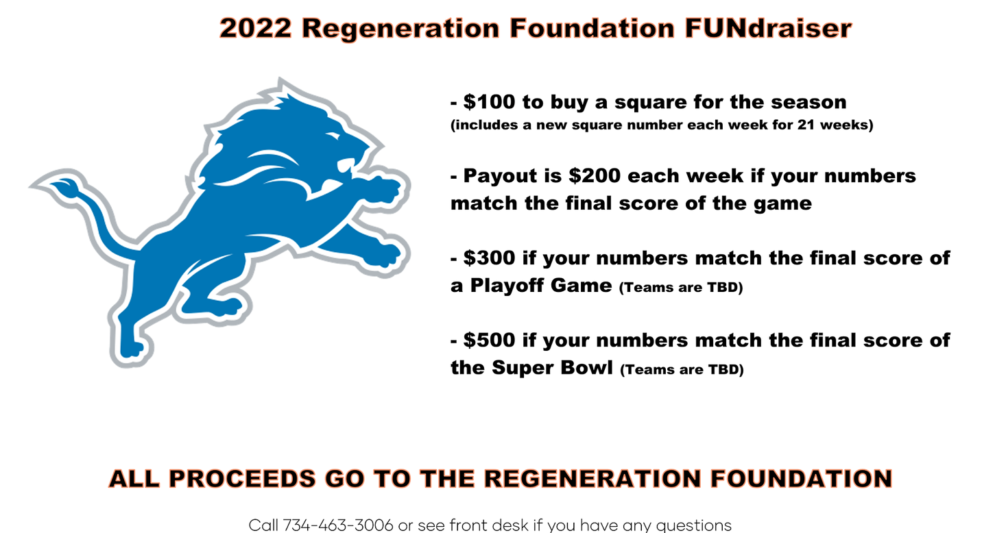

Sept. 11 vs Philadelphia Eagles 1 p.m. | 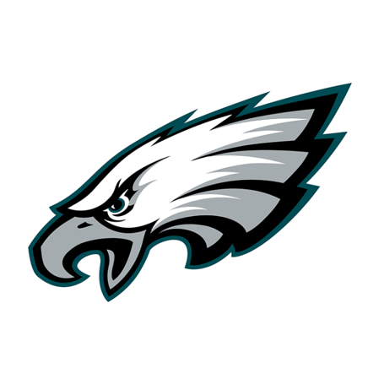
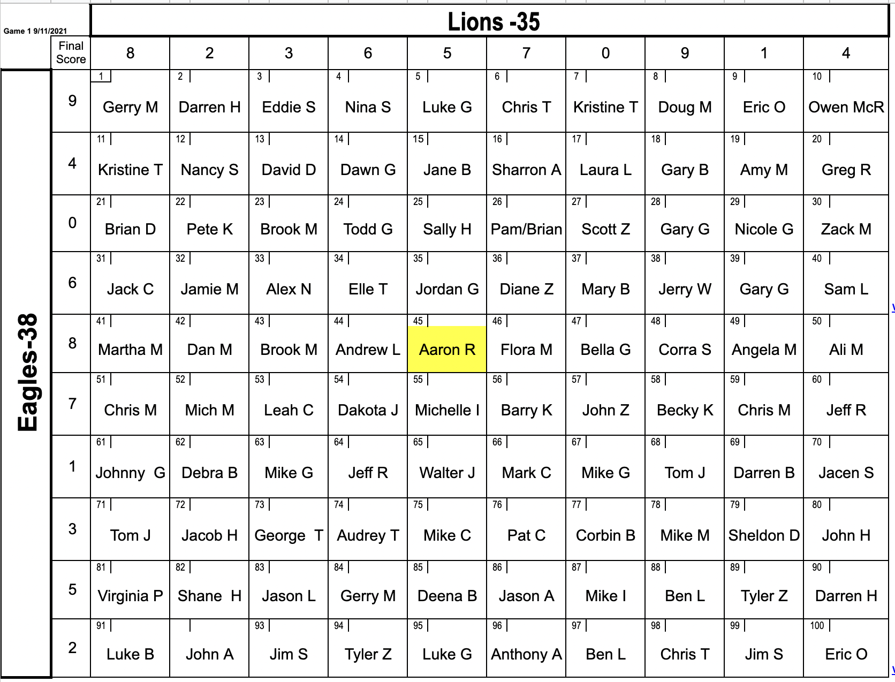

Sept. 18 vs Washington Commanders 1 p.m. | 
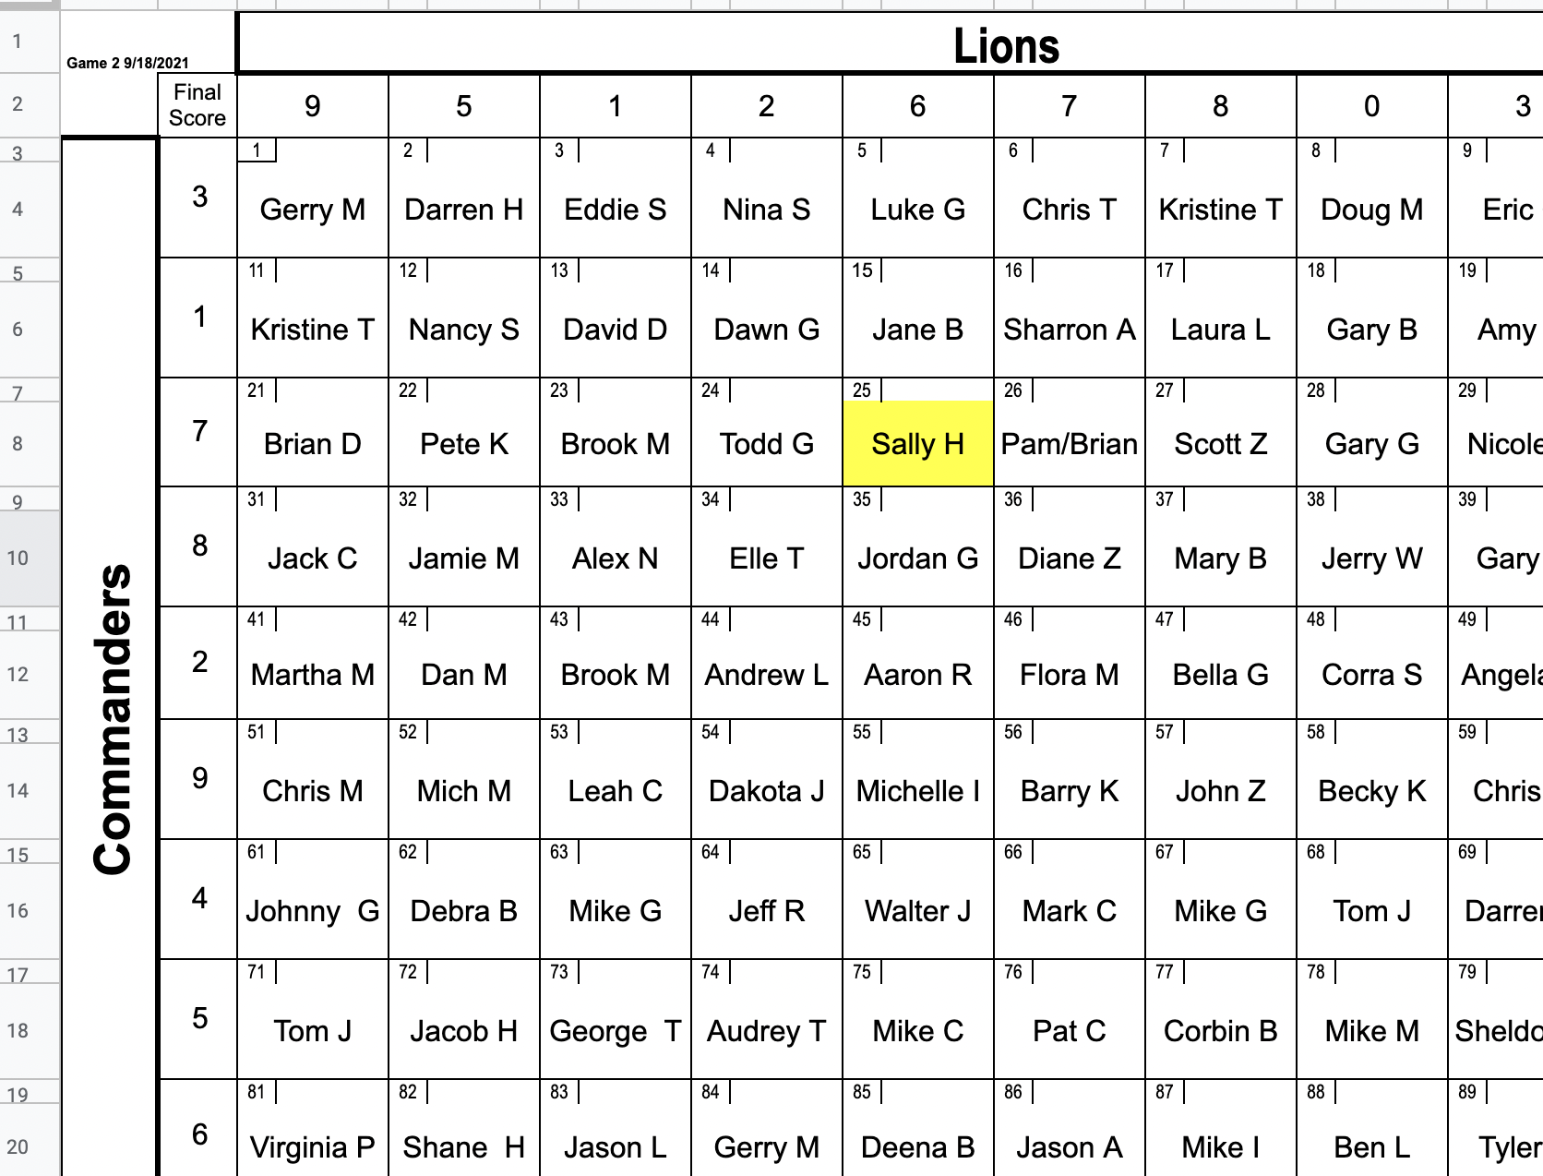

Sept. 25 at Minnesota Vikings 1 p.m. | 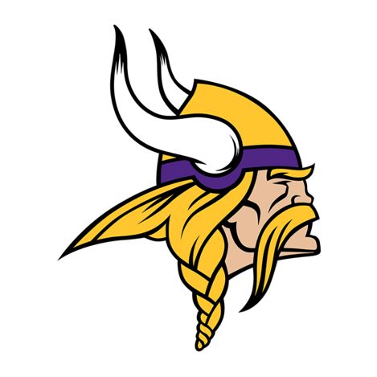
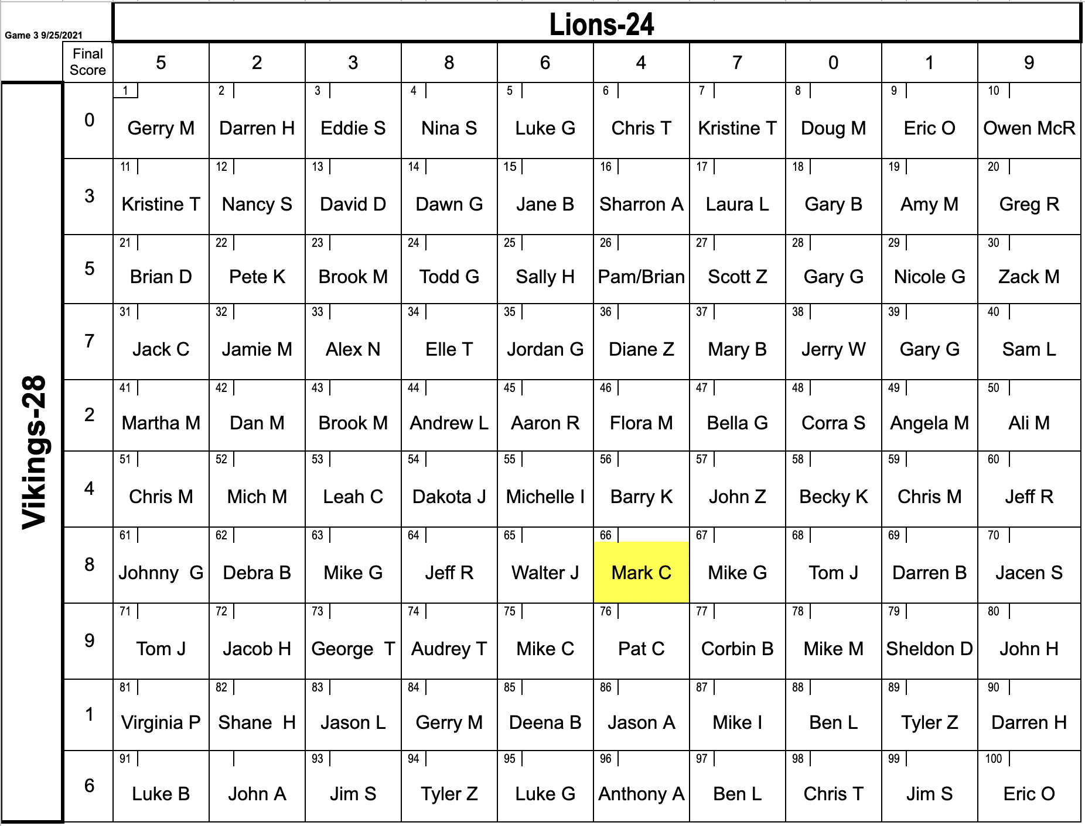

Oct. 2 vs Seattle Seahawks 1 p.m. | 
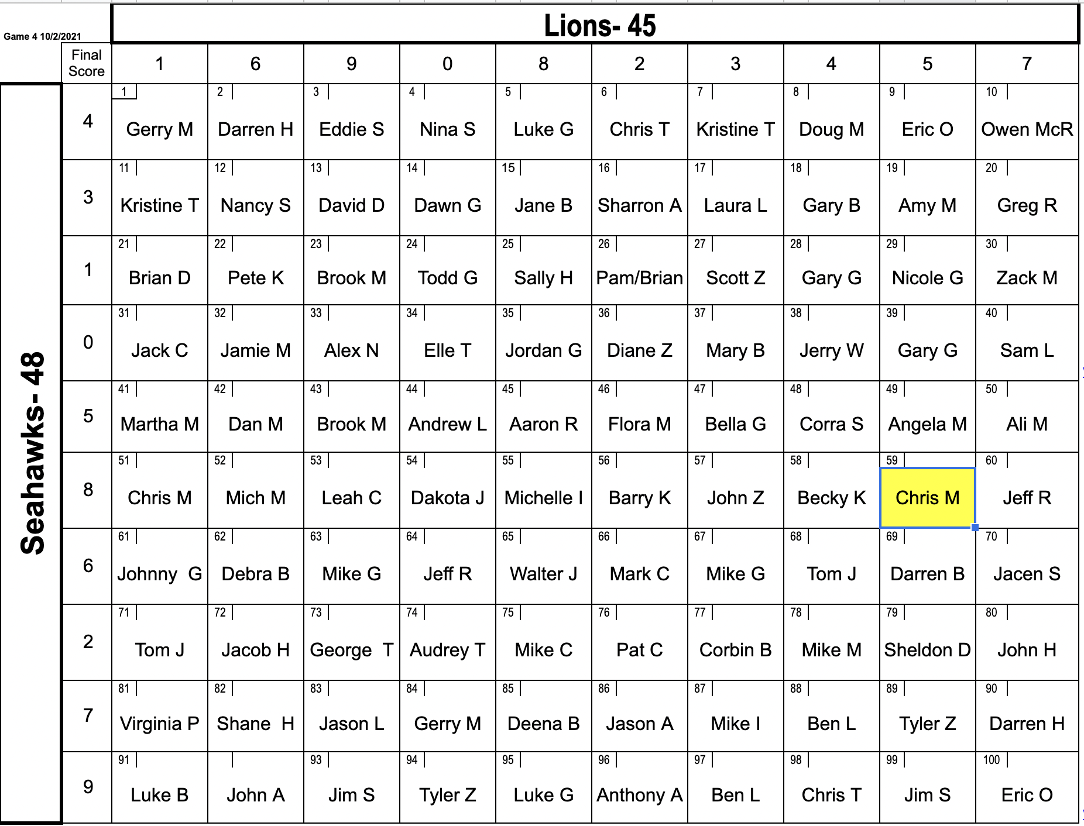

Oct. 9 at New England Patriots 1 p.m. | 
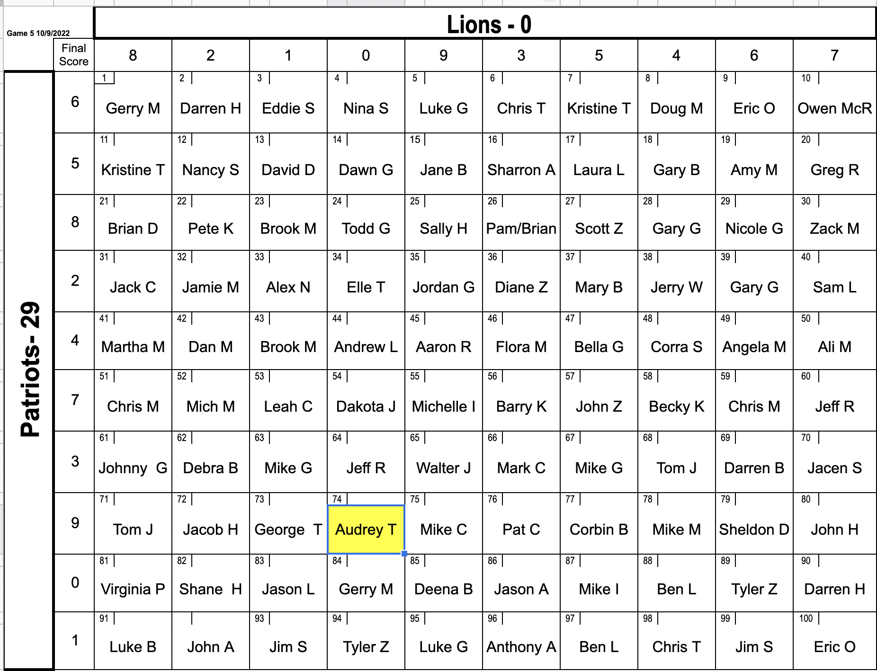

Oct. 23 at Dallas Cowboys 1 p.m. | 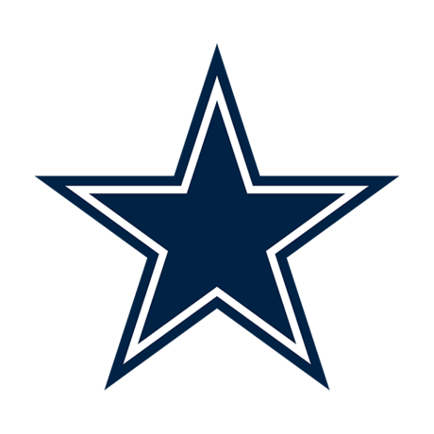
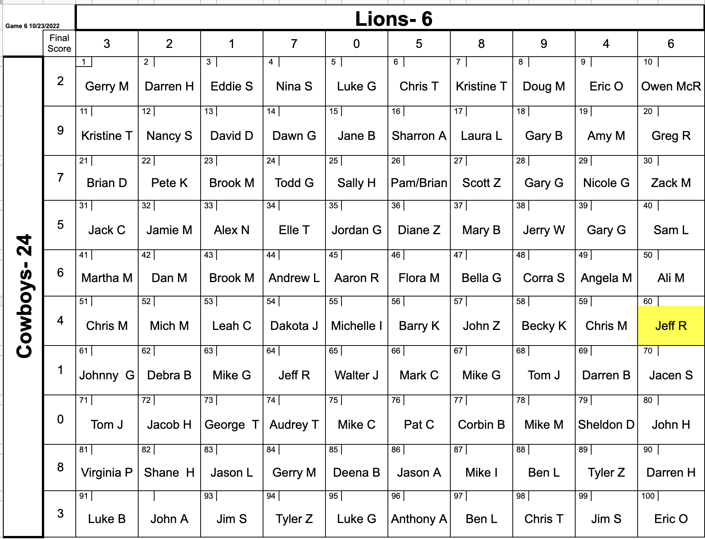

Oct. 30 vs Miami Dolphins 1 p.m. | 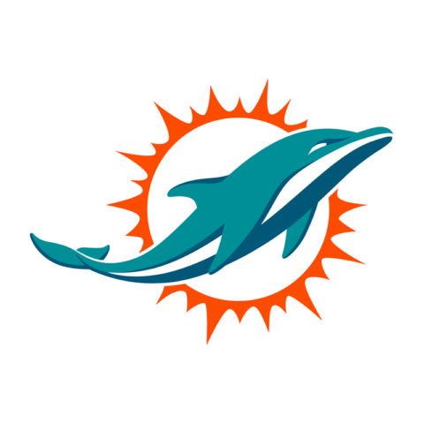
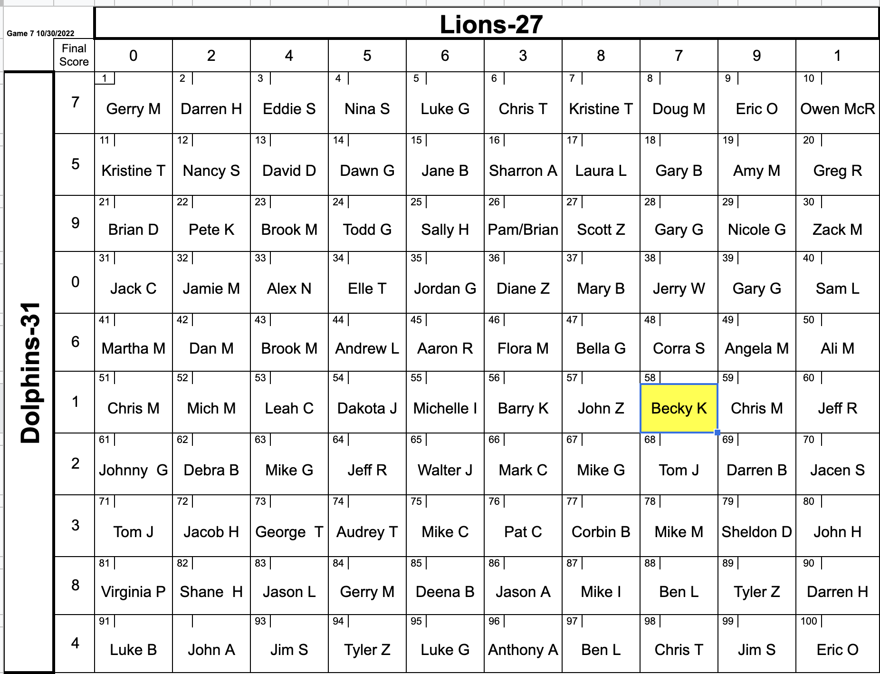

Nov. 6 vs Green Bay Packers 1 p.m. | 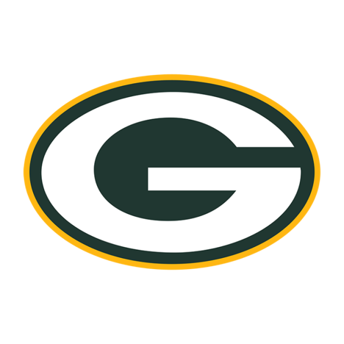
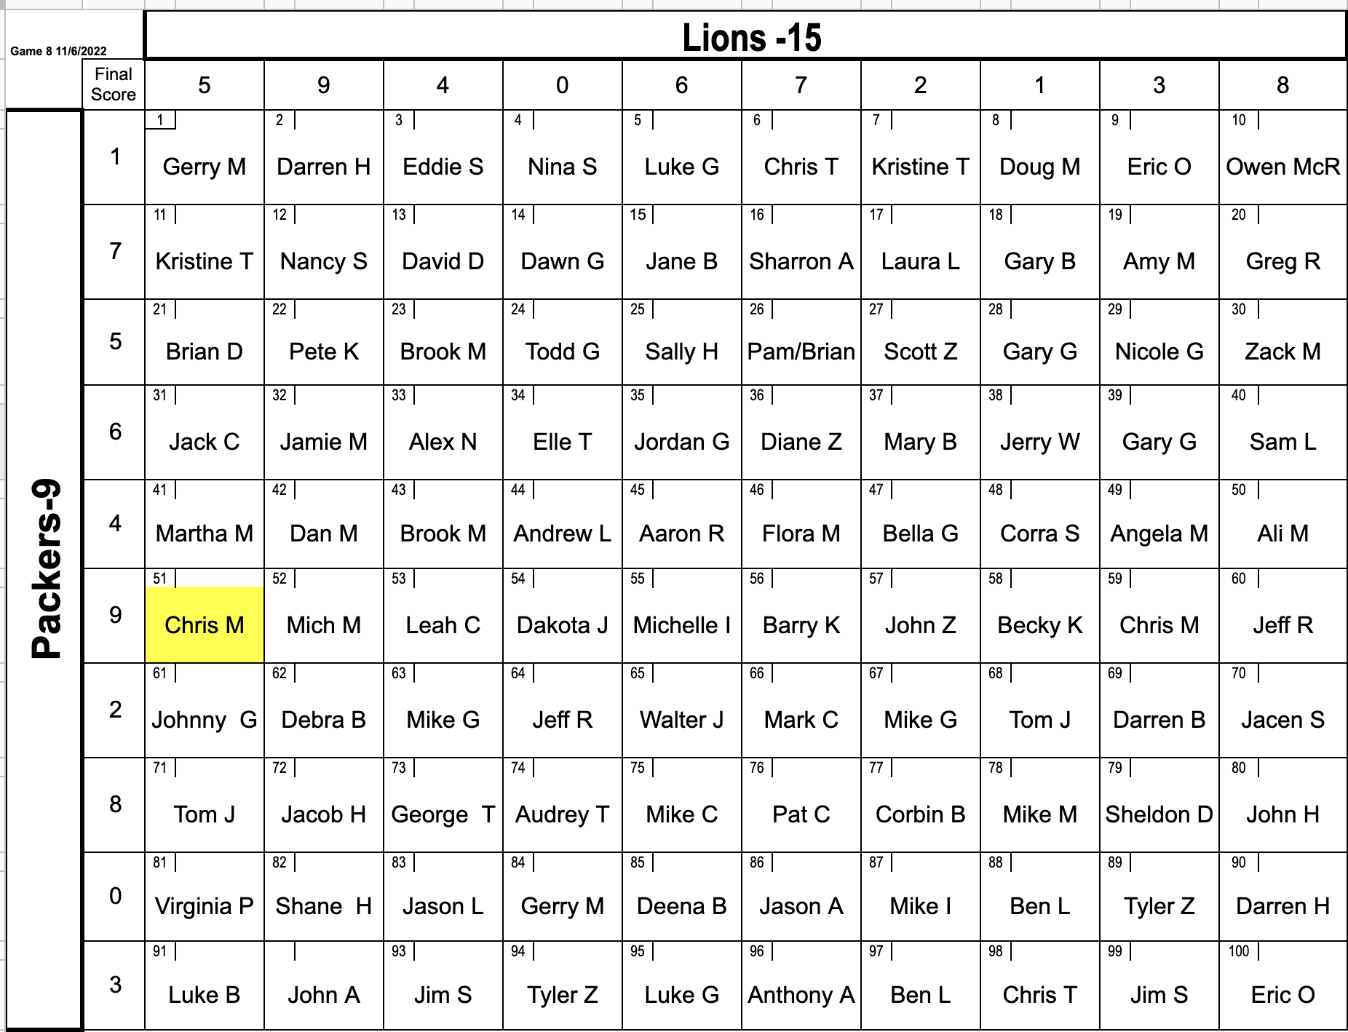

Nov. 13 at Chicago Bears 1 p.m. | 
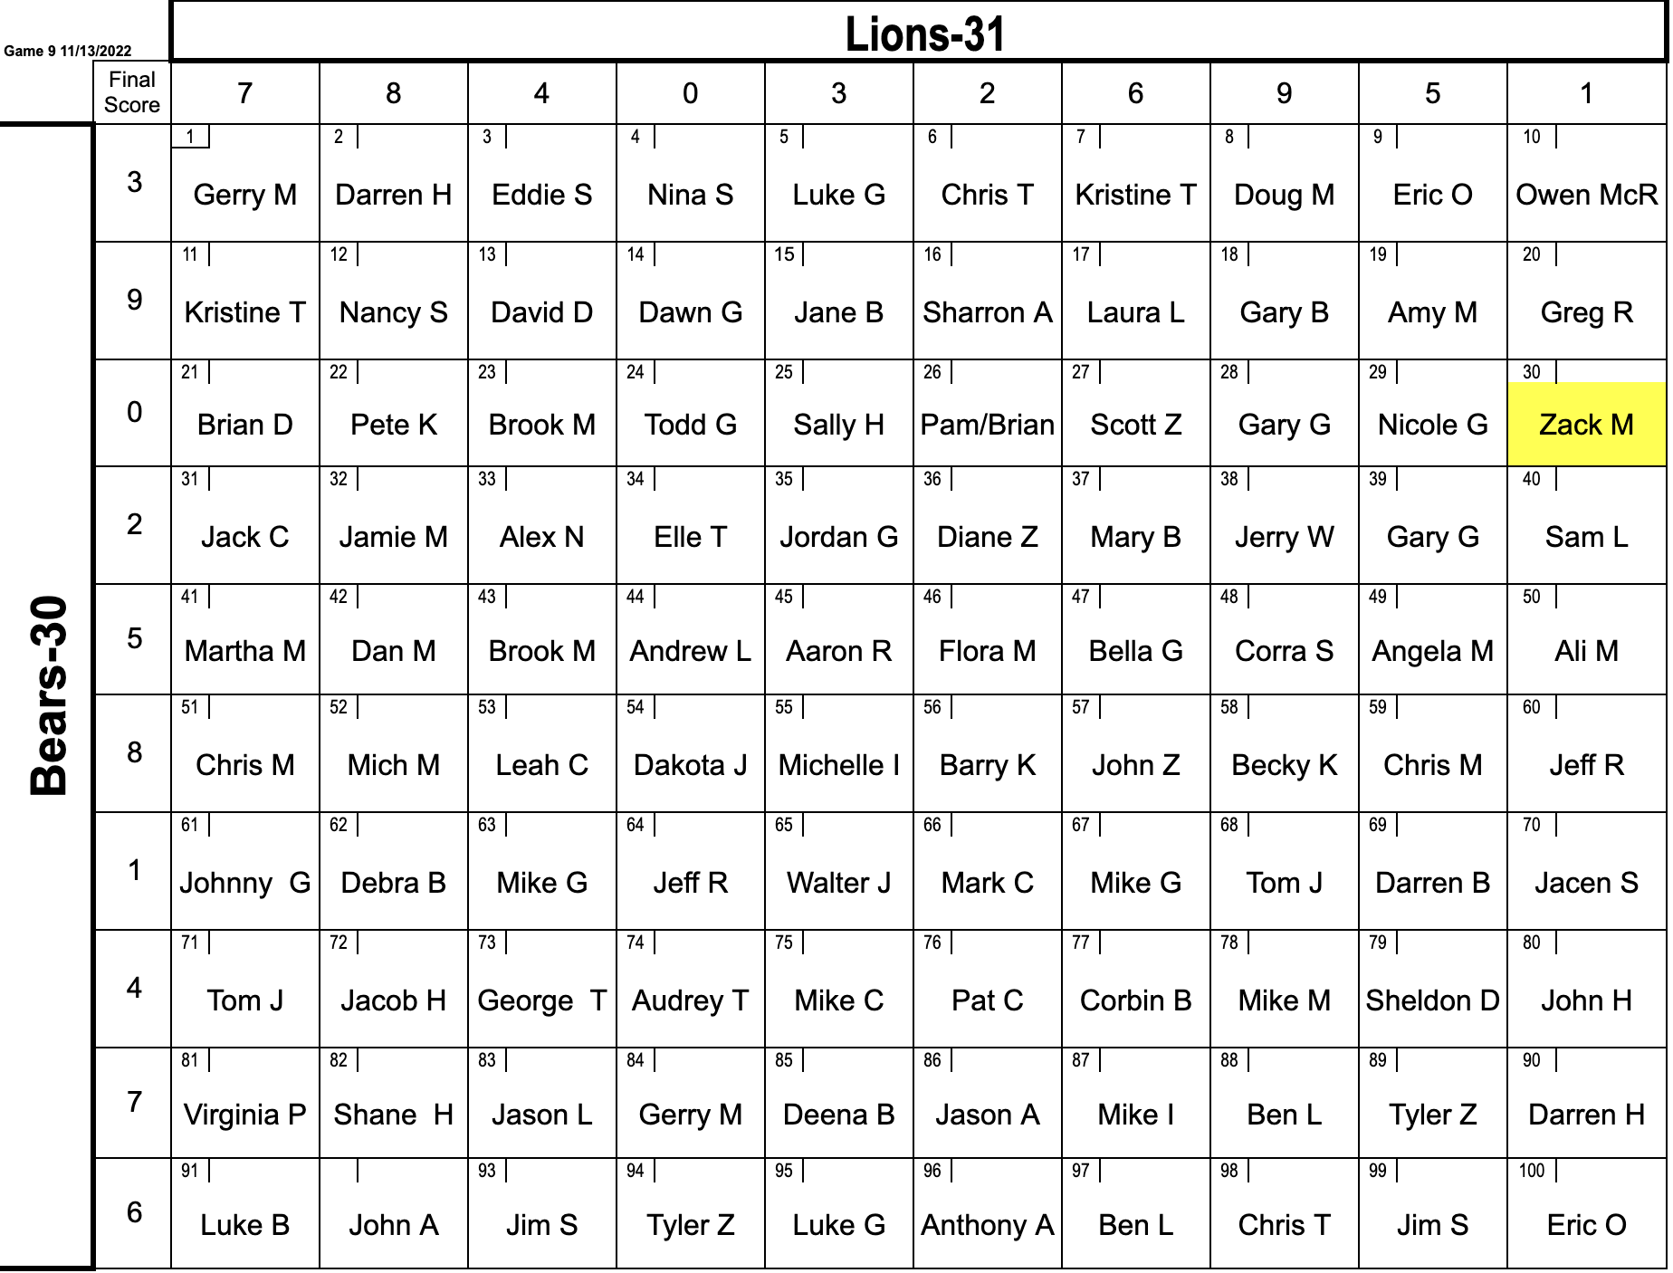

Nov. 20 at New York Giants 1 p.m. | 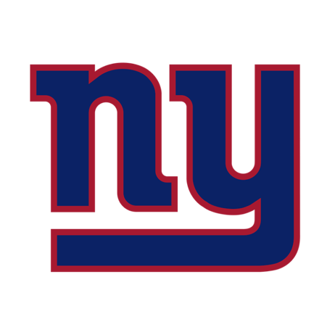
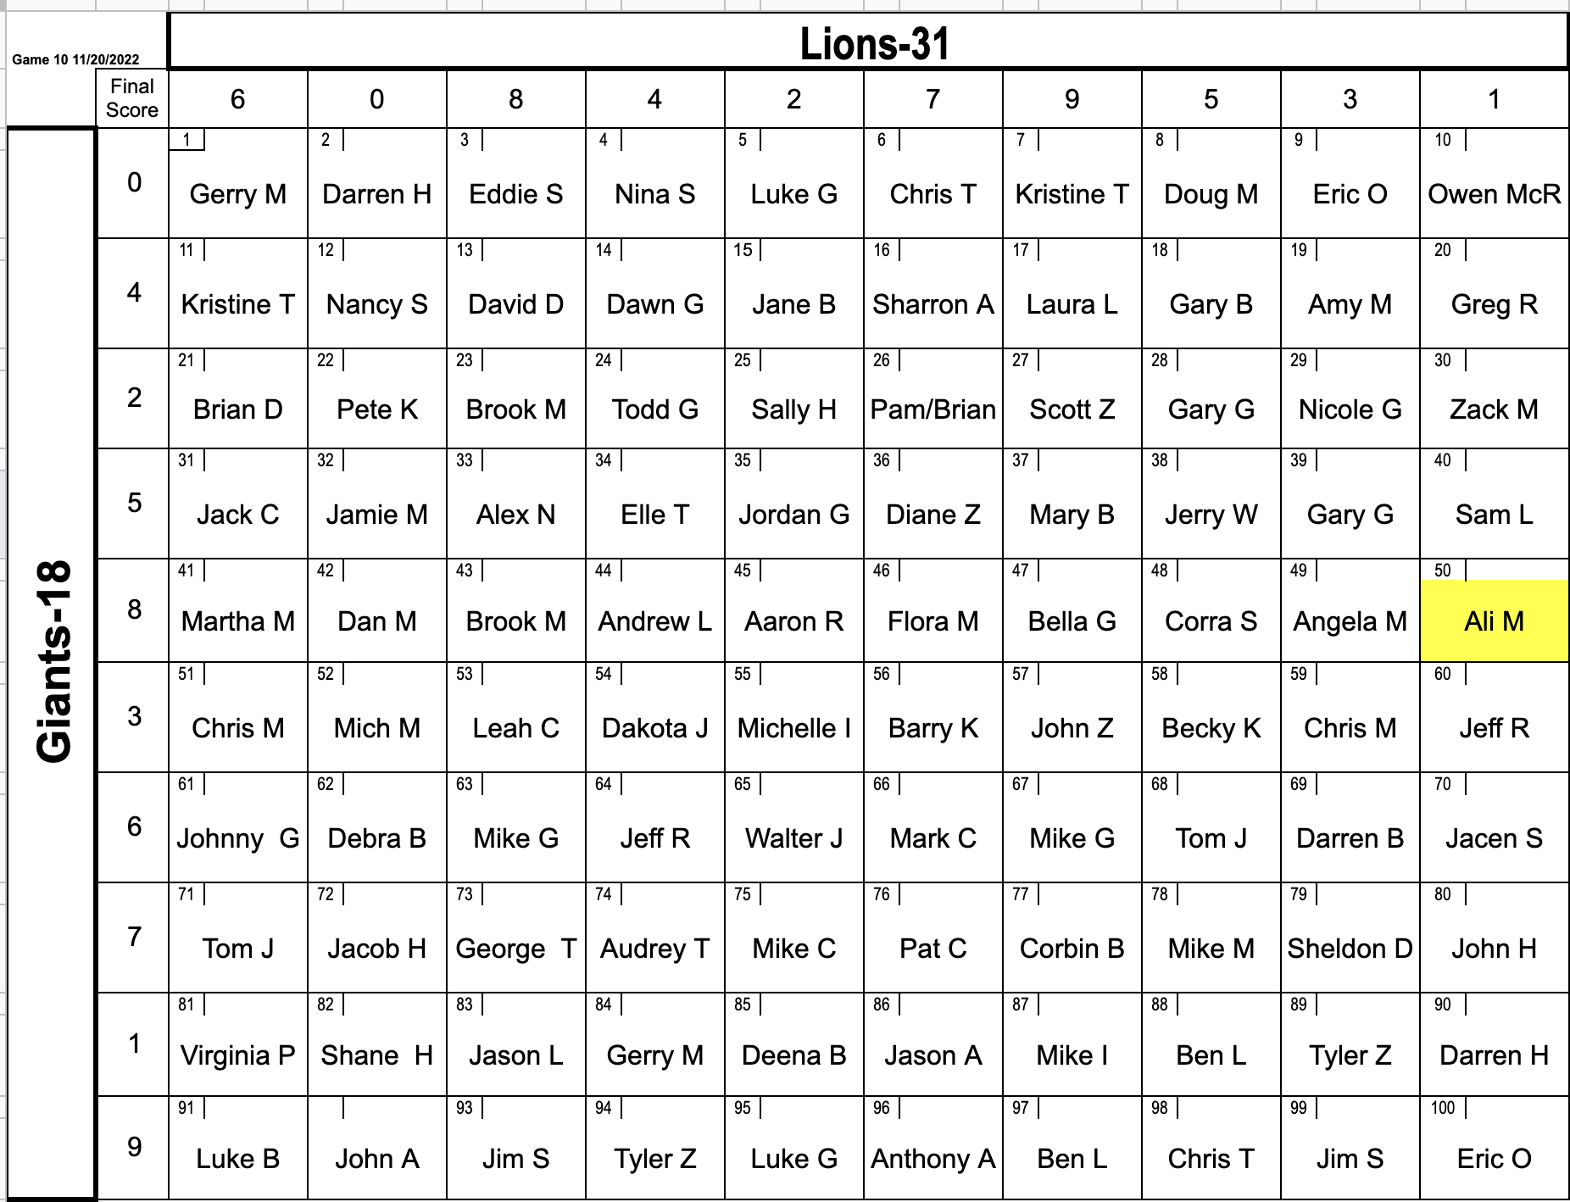

Nov. 24 vs. Buffalo Bills (Thanksgiving) 12:30 p.m. | 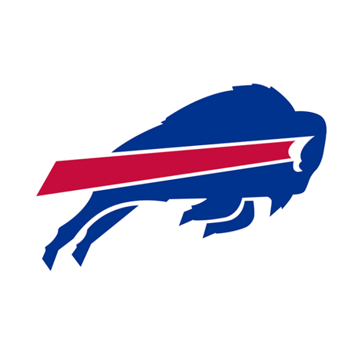
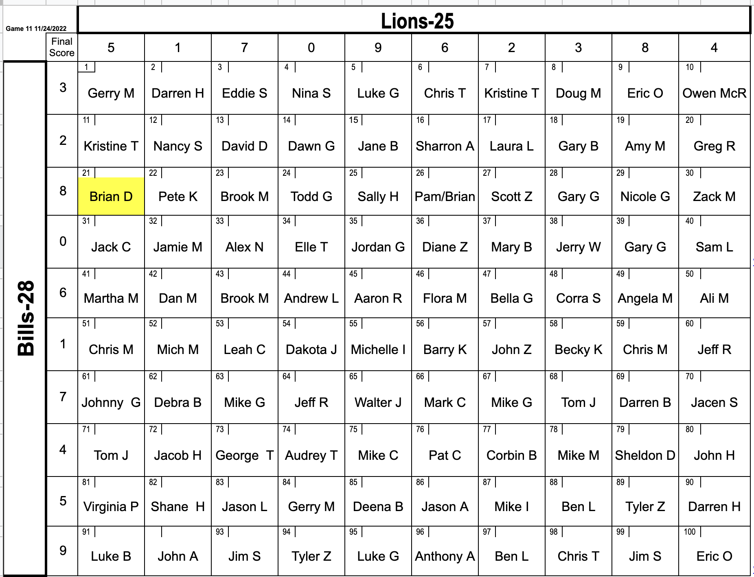

Dec. 4 vs Jacksonville Jaguars 1 p.m. | 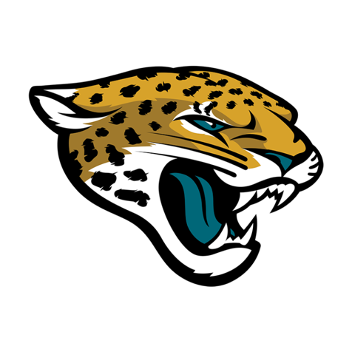
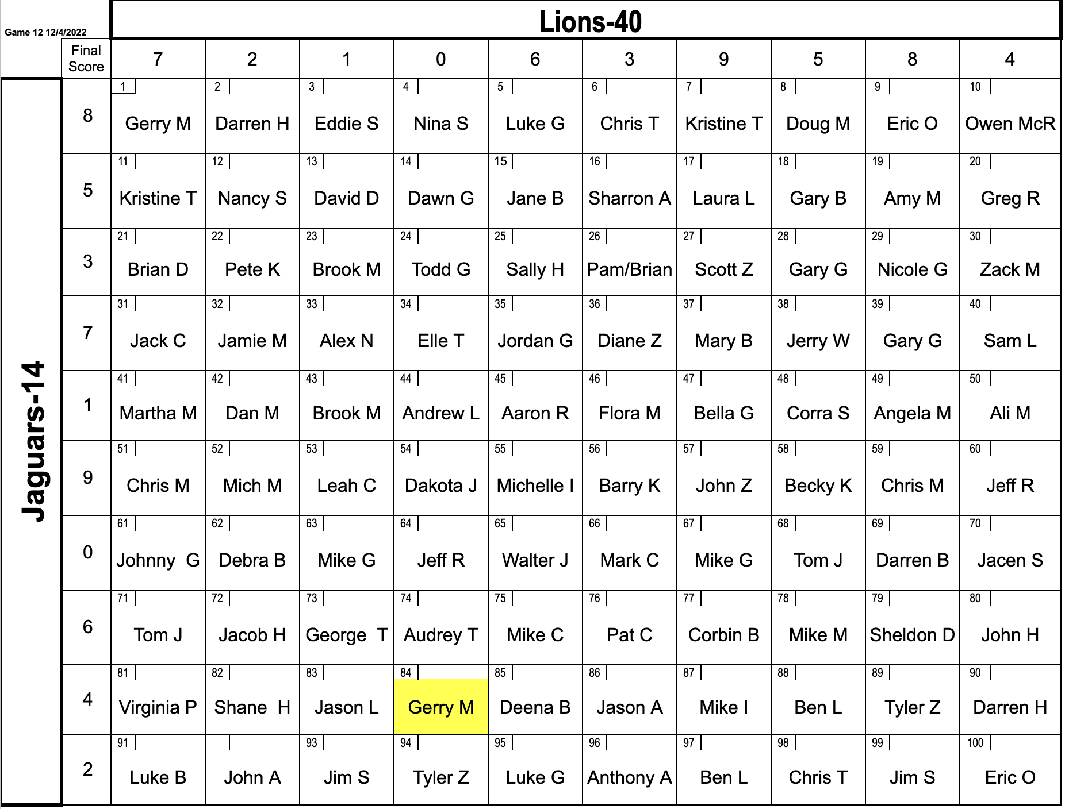
Dec. 11 vs Minnesota Vikings 1 p.m. | 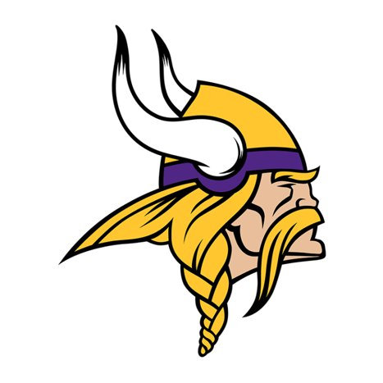
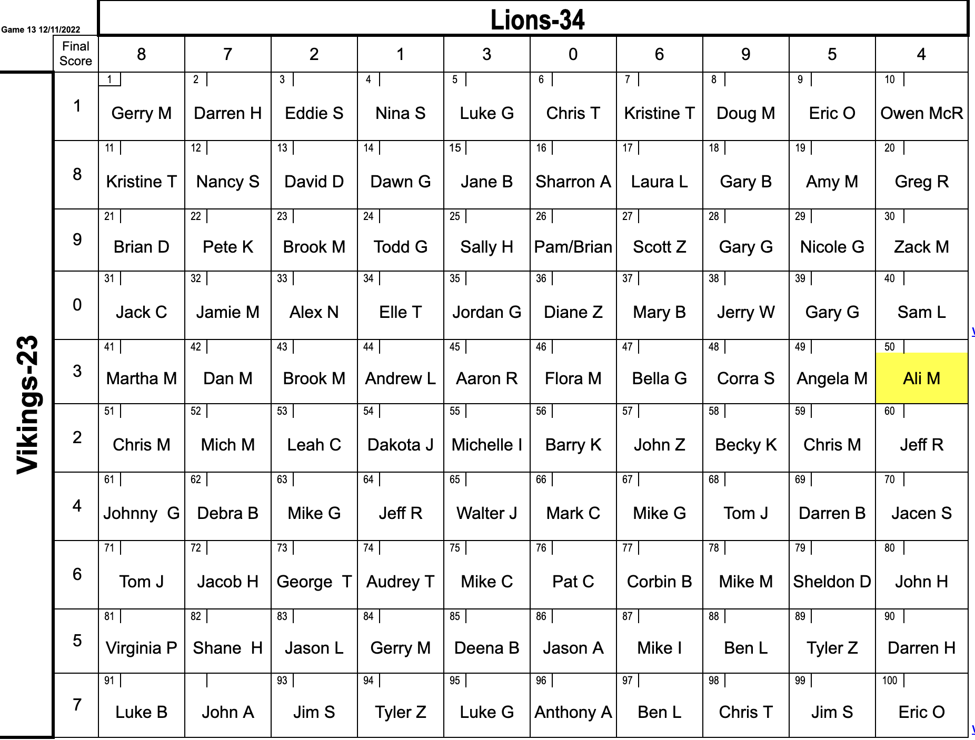

Dec. 18 at New York Jets 1 p.m. | 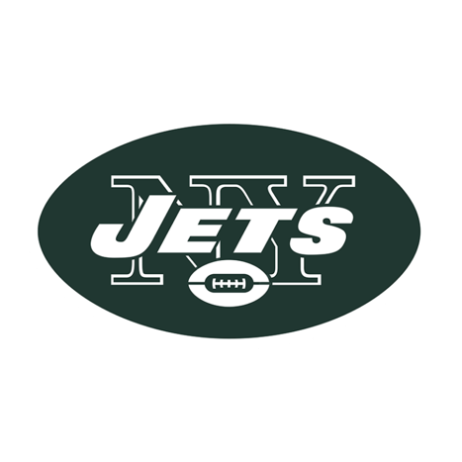
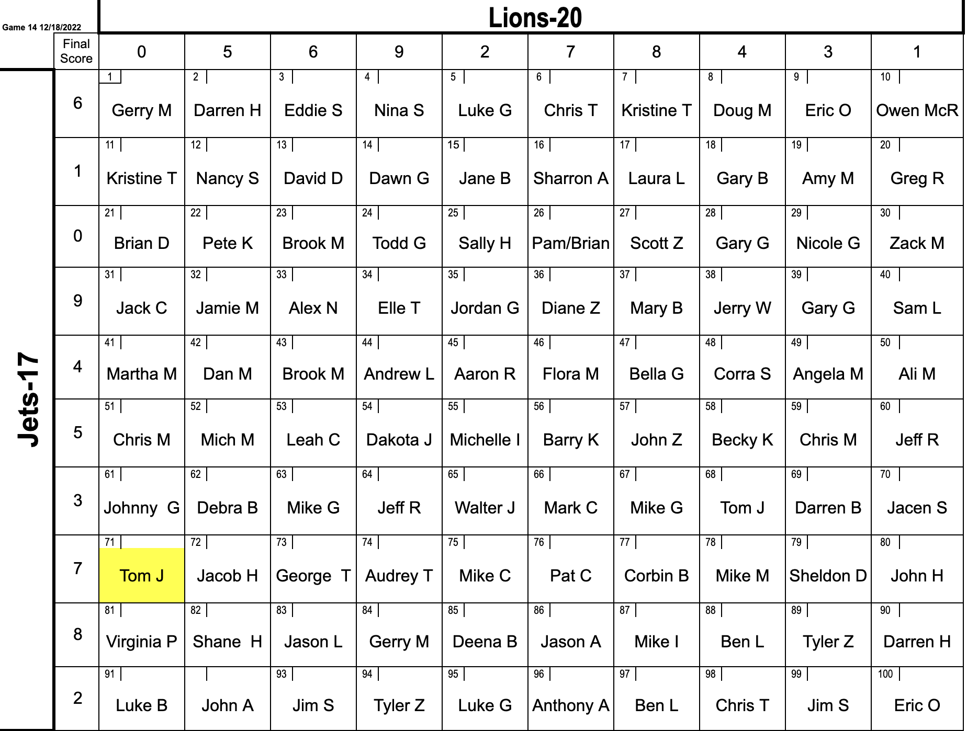

Dec. 24 at Carolina Panthers 1 p.m. | 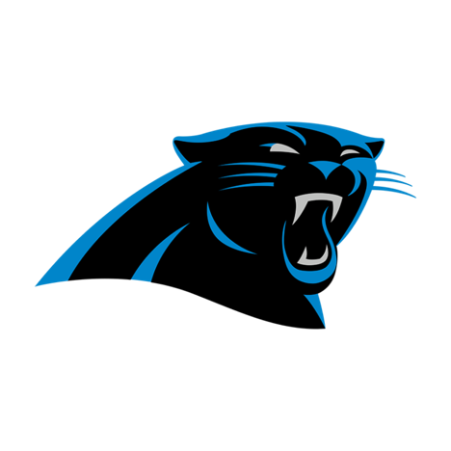
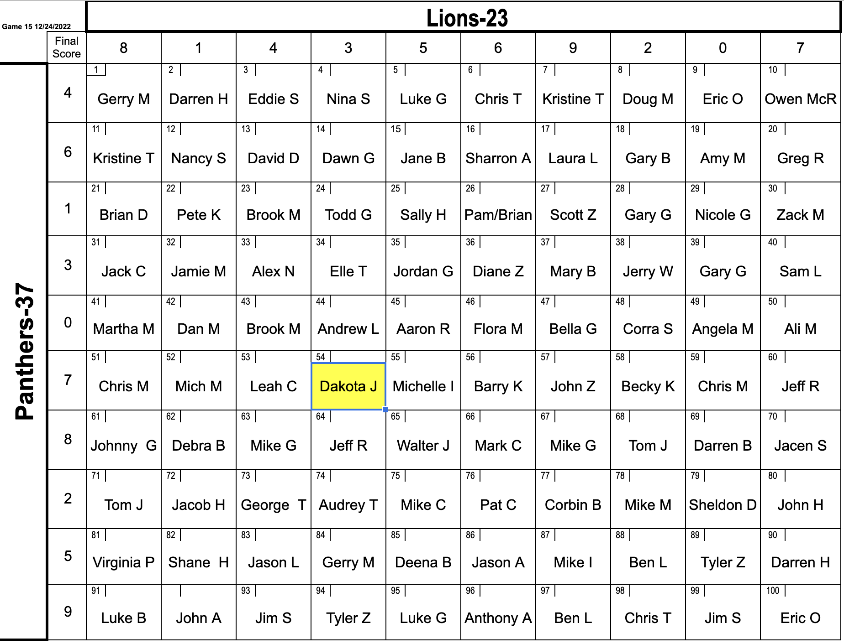

Jan. 1 vs Chicago Bears 1 p.m. | 
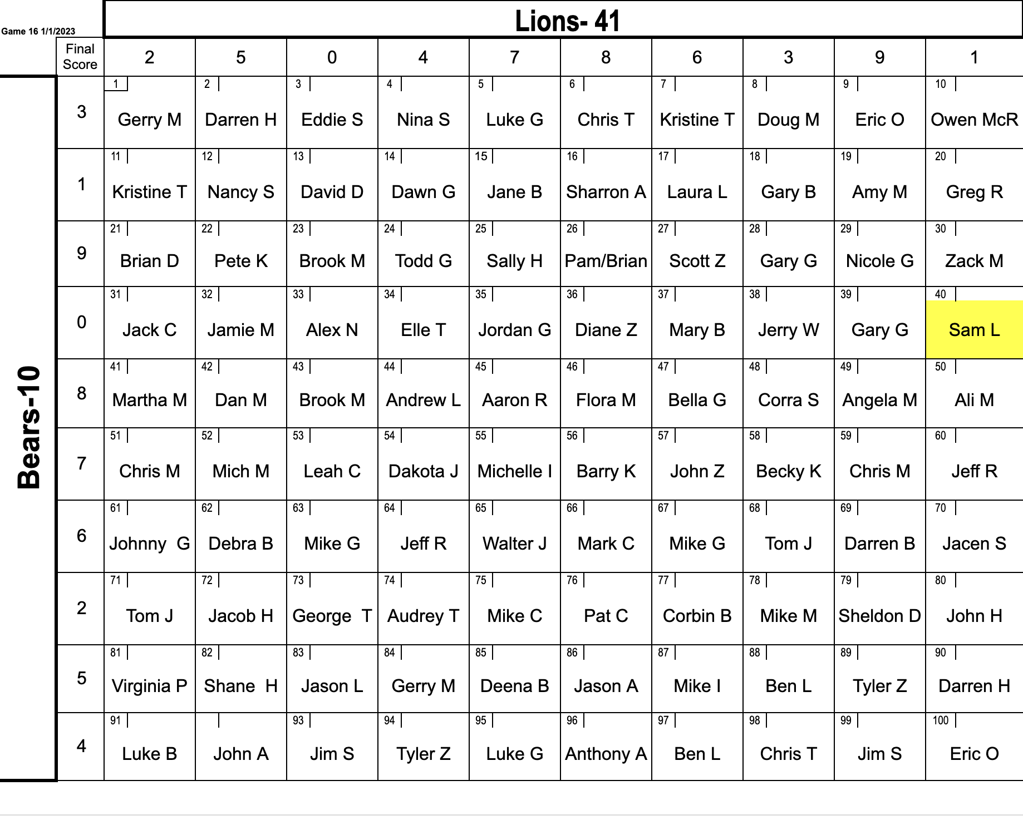

Jan. 7/8 at Green Bay Packers TBD | 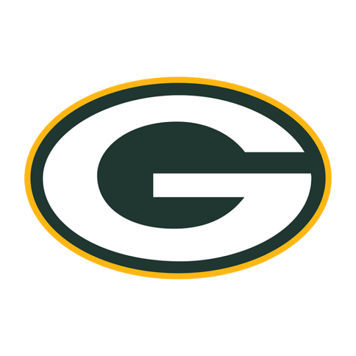
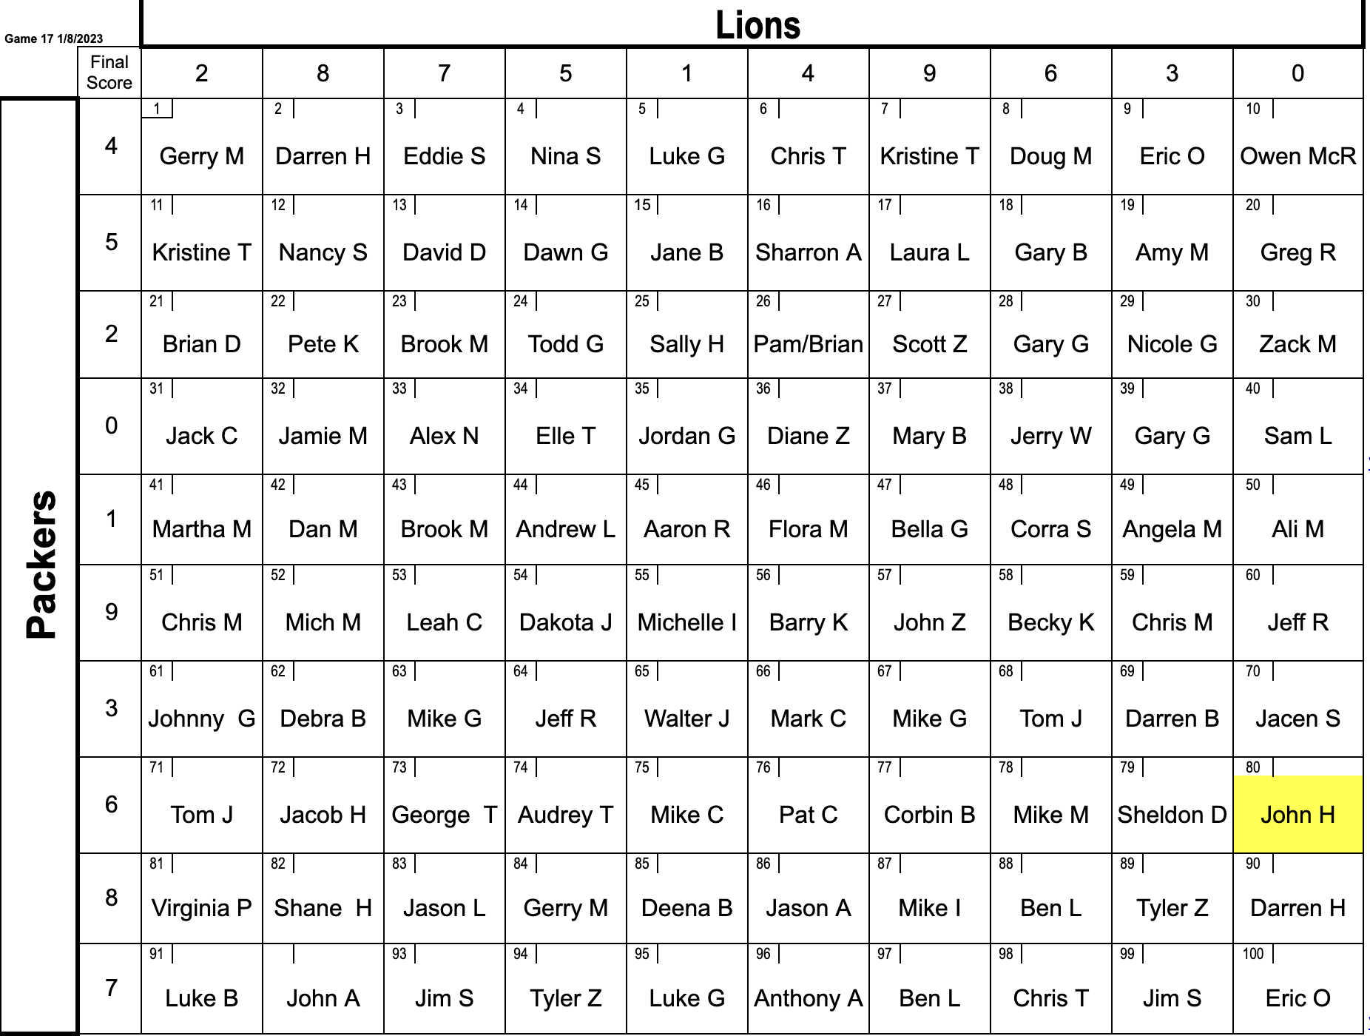

Playoff Game 1 – Seahawks vs 49ers | 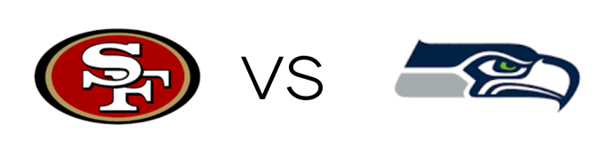
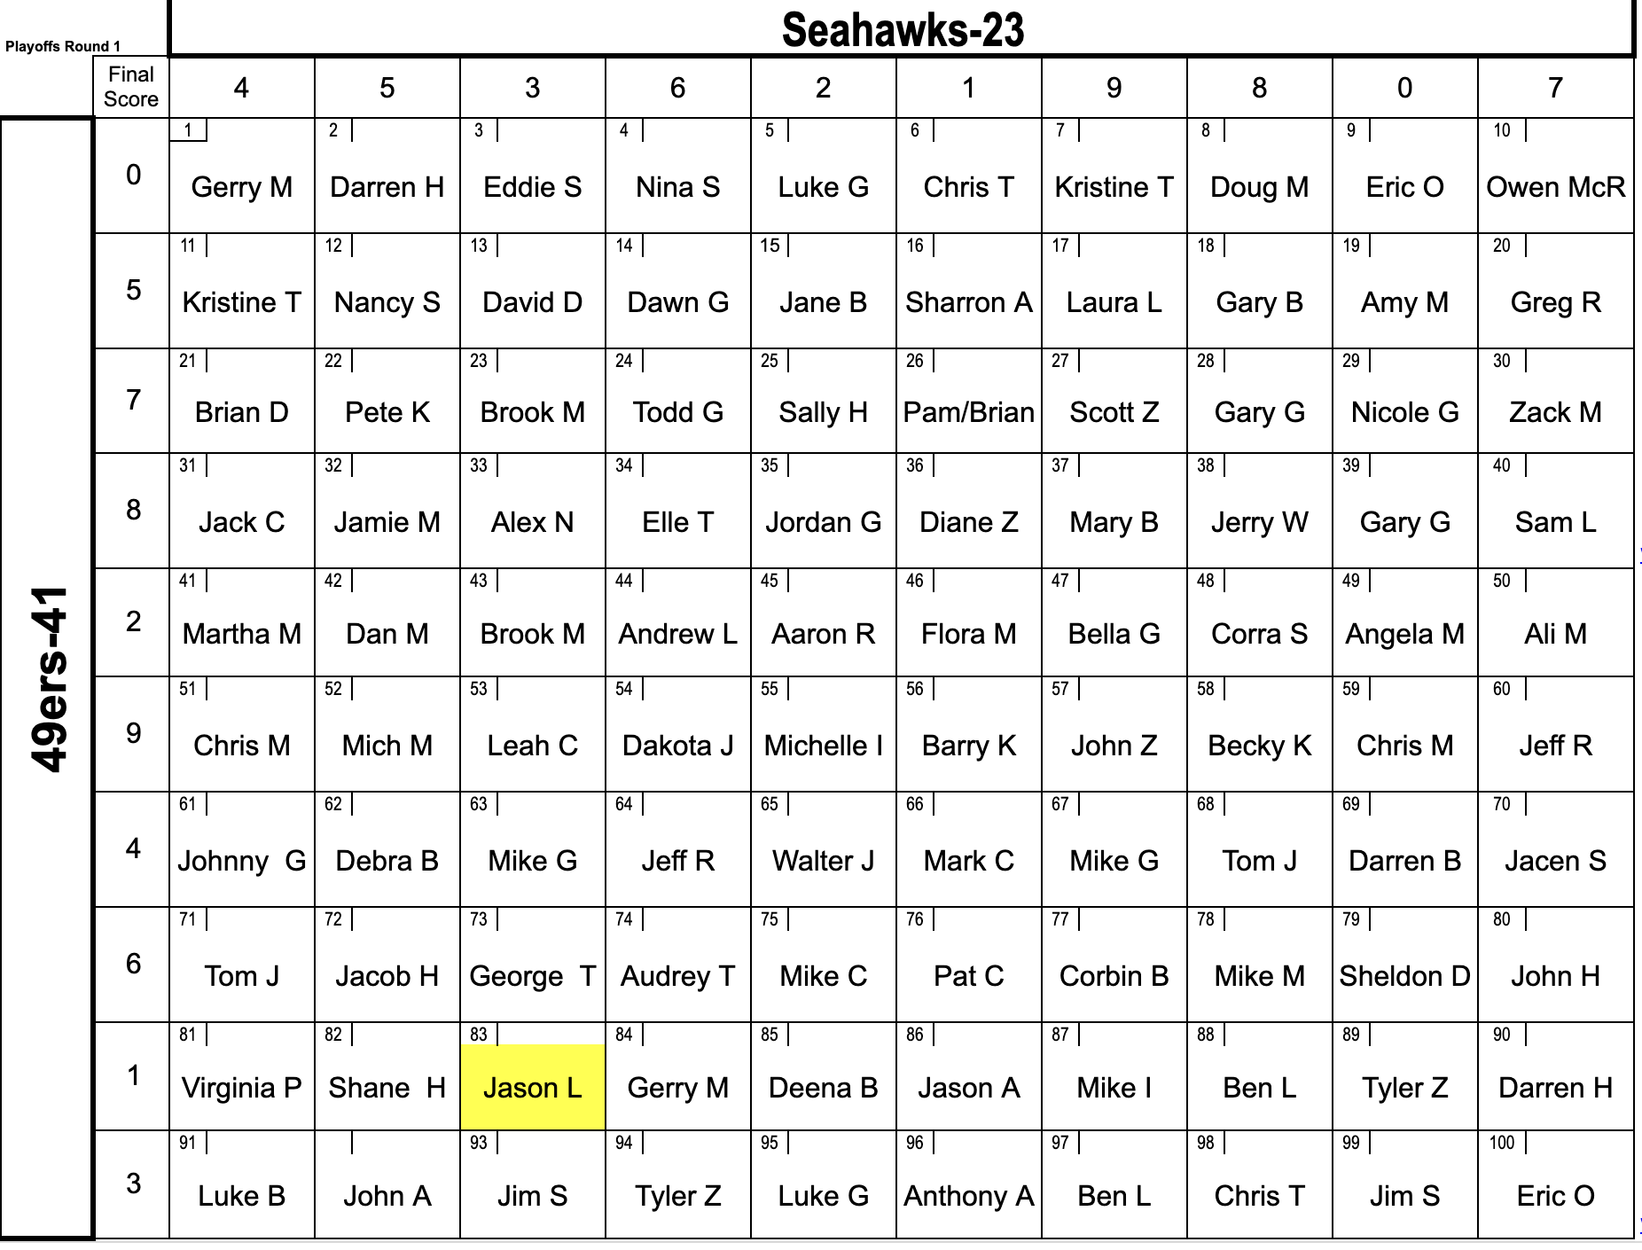

Playoff Game 2 – Cowboys vs 49ers | 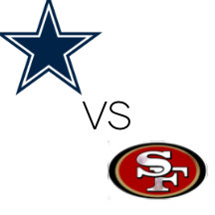
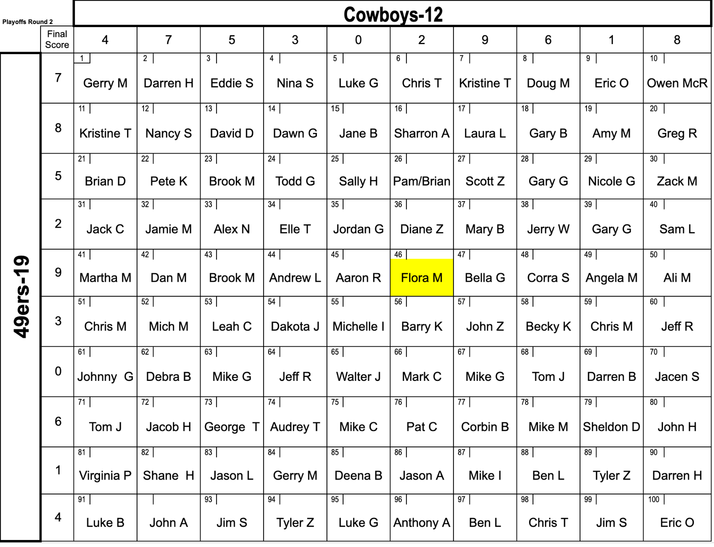

Playoff Game 3 – 49ers - Eagles | 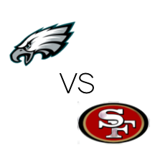
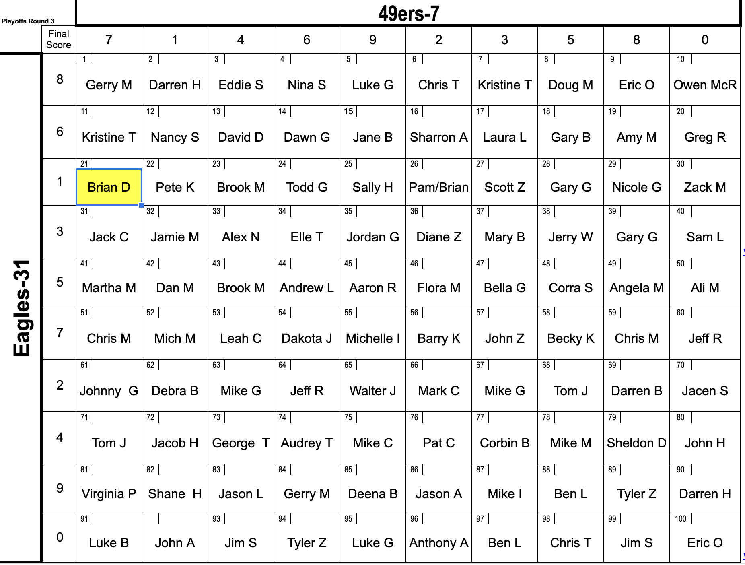

Feb 13th - SUPER BOWL – Chiefs vs 49ers | 